Touch-Free Kinect Assistive System for the Physically Disabled People

Muhammad Munir Albakri, Ahmed Maher Allilly, Faisal Awad Bin Zager, M. Rizwan Jameel Qureshi, Fazal Qudus Khan
Department of Information Technology, Faculty of Computing and Information Technology, King Abdulaziz University, Jeddah, Saudi Arabia
E-mails: hiaimer@hotmail.com, ahmed.allilly@hotmail.com, anriz@hotmail.com, fazalqudus@hotmail.com, binzager@yahoo.com

ABSTRACT

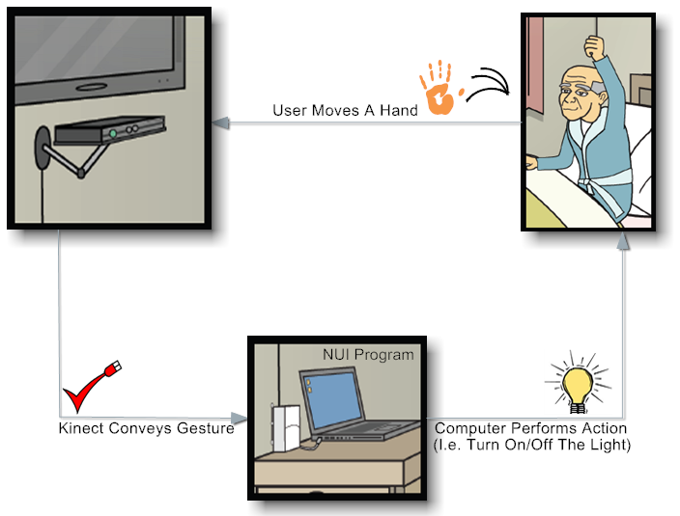
Recent statistics show a rapid growth in the number of aged people and persons with physical disabilities. Surely, they need outer help to carry out their daily tasks. The problem of taking care of those people will become serious in the years to come when a substantial part of the increasing global population will be in the 65-or-above age group. Obviously, this problem cannot be solved by increasing the number of Health Care Assistants (HCAs) because they have an impact on economic growth and public finance. So, there is a pressing need for a more economical, safe and user-friendly automated solution. The main motivation, behind resolving the problem, is the nobility and honor of providing the physically disabled and old people with a service that would make them as comfortable and satisfied as they could be. The available solutions for people are controlled remotely by pressing a button or flicking a switch or picking up a controller. In other words, there has to be a physical contact between the user and the intelligent assistive system. In addition, most of these solutions have control algorithms that are not based on a small number of commands relevant to the user's motions and they are awfully expensive and need to be imported. The objective of this project is to build a more assistive system to increase user's comfort and pleasure. The proposed system is currently under development and it removes the need of physical contact to operate it using Microsoft Kinect for Windows SDK beta. Prototyping technique is used to implement the proposed system to show how an actual light bulb will be turned on/off with just a user's hand gesture detected by Kinect sensor device that is connected to a microcontroller with a program running on it. The light unit, to be manipulated, is chosen based upon results of a field investigation questionnaire that targeted a sample of people with movement disabilities at a hospital in Saudi Arabia. After analysis, the overall results indicated that for controlling surroundings 83.33% of the patients want to control the lights, 41.64% want to control the curtain, 8% want to control the door, and 8% want to control the window. And for wanting to have the proposed Kinect solution 80% of the patients want to use it. Regarding the findings, they are all about usability. First the Kinect sensor has a limited viewing distance, maximum distance is three meters. Second, Kinect sensor is very sensitive against the objects it sees, if an object is closer to the sensor than the user, it starts focusing on it instead of the user. Third, to best utilize the usage of the Kinect sensor, user needs to follow the 90˚ rule in sitting in front of the sensor, and if sitting degree is from 90 to 140 degrees, sensor will be less responsive, and if sitting degree is more than 140˚, sensor will become nonresponsive. All in all, Kinect has great operation stability that compensate its few usability constraints.

